b. Cross-reference with CGC and NCBI
We found that our classifier identifies key driver genes included in the cancer census gene (CGC) list, which was downloaded from COSMIC as a reference list for generally accepted cancer genes. The number of oncogenes, tumor suppressor genes, and driver genes (without regards to type) that are reported as driver genes by both CGC and our classifier are reported in Table 2.
To initialize our analysis of the top genes predicted by our classifier, we ranked the putative driver genes according to their driver scores. Driver scores were calculated as the combined probability of the gene being either a driver oncogene or tumor suppressor gene; this is the equivalent of the fraction of observations of the OG and TSG classes in the nodes of the random forest ensemble. After the putative drivers were ranked, a clear CGC gene enrichment was found for the top ranked genes for the four types analyzed (Table 2). On average, 62.5%, 29.1% and 23.0% of the top 10, 30 and 50 selected genes were CGC documented driver genes. The first column of Table 3 reports the names of the top fifteen putative driver genes that are also reported CGC driver genes; the second column reports the number of publication hits in NCBI which are found to be relevant to a query cancer type plus a query gene. The top CGC-validated putative genes are apparently more likely genes that have well-documented relevance to the cancer type.
Cancer Name | # OG overlap | # TSG overlap | # drivers overlap | Recall: top 10 | Recall: top 30 | Recall: top 50
Colorectal | 26 | 12 | 66 | 70.0% | 33.3% | 24.0%
Pancreatic | 17 | 12 | 51 | 50.0% | 20.0% | 18.0%
Breast | 32 | 12 | 75 | 70.0% | 33.3% | 26.0%
Melanoma | 35 | 13 | 80 | 60.0% | 30.0% | 24.0%
Table 2. Performance of synthetic data-validated random forest classifier on driver gene classification in individual datasets of TCGA cancers.
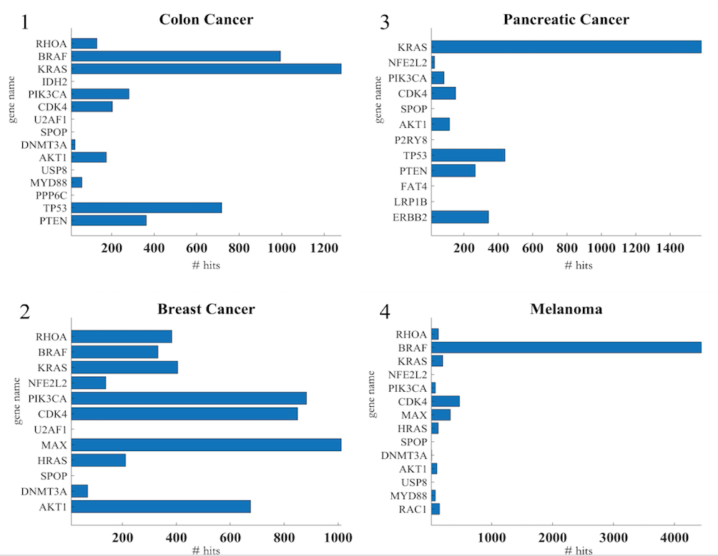

Table 3. The names and NCBI publication hits of the top fifteen ranked putative genes

